**Architecture Diagram:**

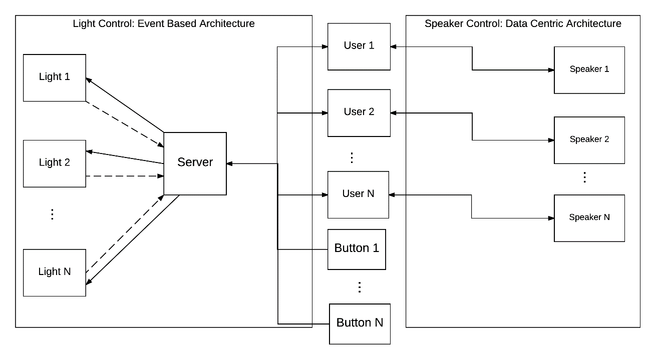

**Description:**

Our system works off a data-centric and event based architecture system. The users and Dash buttons communicate with the server by emitting events such as entering rooms, leaving rooms, and button presses. The server dispatches these events to the appropriate light to turn it on/off. To control speakers and handle configurations the system uses a data-centric design. When the user enters a room, the app requests the address of the speaker in that room from the server. Any account creation and preferences changes are also done through a data centric model.